Year 1 children from Damers First School took part in a nature project that was organised by The Harmony Project, funded by the Aurora Trust. The project asked schools to choose an activity that would encourage children outside to learn from nature.
The children had the idea of rewilding an area of the Great Field Poundbury from book they read in school called ‘The Secret Sky Garden’ by Linda Sarah.
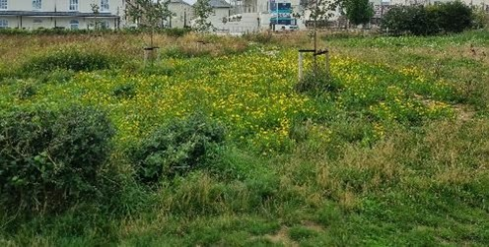
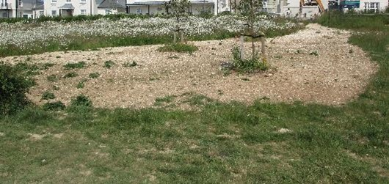
They picked wildflower seeds and later sowed them on a bare piece of land on the Great Field. The Duchy of Cornwall had given permission for the children to re-wild the area turning it into “Damers’ Meadow”.

The children then made Nature Journals where they documented wild flowers, vegetables, insects, birds etc from what they saw in the school grounds.
The Great Field bloomed, attracting many bees and butterflies.
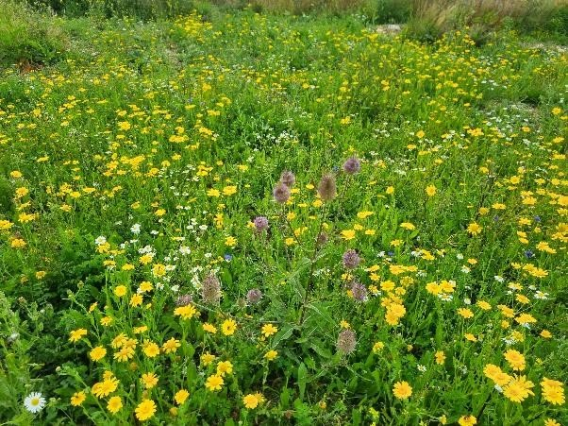

They then planned on getting a Nature Information Board for the Damers’ Meadow to help inform and educate the community and visitors about the wildflowers, insects and birds they might see around them.
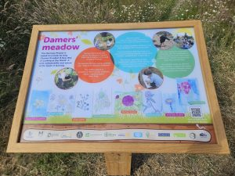
The children raised the money with donations from organisations and businesses. These included Dorset CPRE, Mansel Pleydell Trust, Poundbury Community Trust, Poundbury Rotary, Dorset Gardens Trust, Dorchester Town Council and Jane Goodall Roots and Shoots Programme.
Nick Morris from Wallis Agency on Poundbury worked with the children to put the nature board together. They included their art work of wildflowers that people might find in the meadow.
There is a QR code that will take people to identification sheets and apps to help them learn even more about what they could discover around them.
Swift Signs in Weymouth did a fantastic job in designing and building the solid oak stand and board. Morrish Homes installed the Oak Nature Information Board for us.
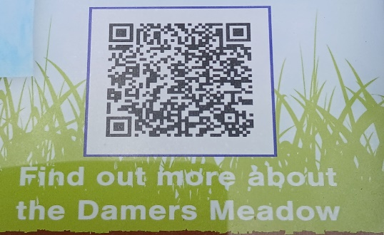

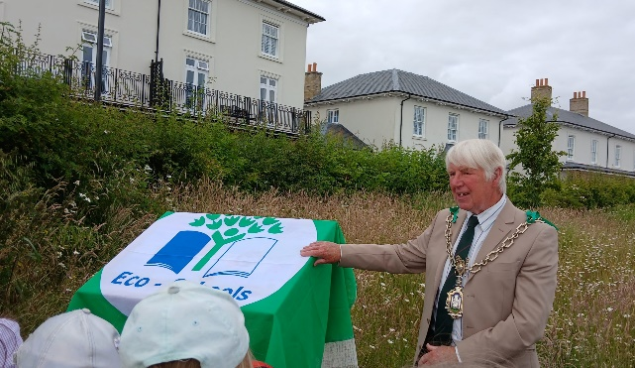
The Nature Information Board was unveiled by Dorchester Mayor, Robin Potter, on Friday 28th June 2024. Present were representatives of the organisation’s who had sponsored the board and Dorset Councillors, Dorchester Town Councillors, the Poundbury Estate Manager and Damers Staff, Parents and children.

